1 | Introduction
This handbook is a tool to help you help yourself. The purpose of sharing the handbook is to provide you (the reader) with information, tools, and resources to help you make informed decisions about your relationship with money.
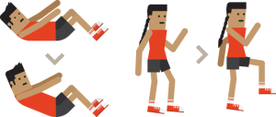
When you’re physically fit, you are able to enjoy activities like running, hiking, and playing sports. People don’t stay physically fit without working at it: you have to train. The same is true for financial fitness.
As our elders have taught us, when we are learning, it is important to look at the past, present, and future. We need to acknowledge our past and understand how it influenced the present situation so we can move forward to creating our future. In respect for that teaching, we share the journey of financial literacy by looking through the lenses of the past, present, and future.

Past
It’s important to note that pre-contact Aboriginal people were a strong and vibrant self-sustaining people. We lived off the land in harmony with nature and with one another. We had assets and items for trade, and we had strong values that guided how we used our assets and how we traded with others.
Our wealth was not measured in “bling” like fat wallets, fancy houses, fast cars, nice jewellery, or credit cards. Our wealth was measured in our ability to manage and sustain our resources. We demonstrated our wealth through caring and sharing with others.
The potlatch system is an example of financial literacy in a pre-contact context. We showed our wealth by giving and sharing. Wealth was managed through potlatch and it worked ― we did not have the poverty and dependency we have today. Our people had clothes on their backs and food in their bellies. In 1884, the potlatch system was banned and so were our teachings about wealth management.

Present
Today, many Aboriginal people struggle with dependency and poverty. Some people are stuck in a “welfare” mindset and some work very hard to get out of poverty but can never get ahead. Others make a decent living but barely manage to get from one pay cheque to the next.
Without the potlatch system, we are missing our teachings about wealth management. We need to look for new ways to learn about money and how to manage it. With today’s technology, we have access to telephone and online banking, electronic tax filing, and other options for saving and investing our money. Many resources are also available for learning how to manage money.

Future
Just like our ancestors, we have the ability to be wealthy. We can access support and services to learn how to make our money work for us instead of us working for our money. When we have the skills, knowledge, and confidence to make smart decisions about our money, we can achieve our financial goals.
In the spirit of potlatch, our friends at AFOA BC share this handbook and the knowledge within its pages with you.
LINK to VIDEO: (10:23)
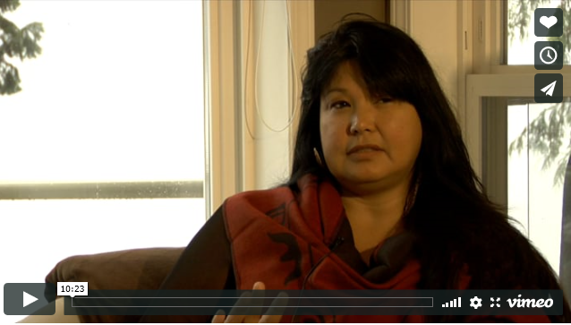

Link to VIDEO: (4:12)
Jennifer: A young woman who is well established and on her way to reaching her financial and life goals. She shares her receipt to becoming financially fit.
Link to VIDEO: (5:20)
This video clip features a family on dealing with real life challenges related to money. The clip highlights what happens when one person in the family makes poor decisions and how it impacts relationships.
Link to VIDEO: (2:36)
This clip features the same family and money challenge but offers a healthier way to tackle the money issue.

